- Unlocking the Cause of Mass Reproduction of Jellyfish and Contributing to the Development of New Materials -
KIOST Unlocks the Secrets of Jellyfish Through Genetic Analysis

The Korea Institute of Ocean Science and Technology (KIOST, President Kim Woong-seo) announced that, by conducting a genetic analysis of DNA from Nomura’s jellyfish (Nemopilema nomurai), it has obtained genetic information on the jellyfish’s proliferation regulator and venom proteins.
Although jellyfish belong to the cnidarian phylum, along with hydras, corals, and sea anemones, they are unique in that they drift on the oceans, while other cnidarians spend their lives in a fixed location, and can adapt themselves to rapid changes in their marine ecosystems.
Among jellyfish, Nomura’s jellyfish, which have strong venom, has been rapidly increasing in number in the summer every year since 2000, causing enormous damage to fisheries and beaches. The cause of this population growth is assumed to be attributed to an increase in water temperature or decrease in natural enemies due to global warming. As such, we have no biological information on this increase in population.
Dr. Yeom Seung-shik, principal research scientist of KIOST, and his research team decoded the genome of Nomura’s jellyfish collected by KIOST’s Marine Science Station in Tongyeong City, Gyeongsangnam-do, in cooperation with Professor Park Jong-hwa of the Korean Genomics Industrialization and Commercialization Center of the Ulsan Institute of Science and Technology (UNIST). As a result, they discovered genes related to the retinoic acid signaling system¹ (signaling agent that plays an important role in the transformation of jellyfish polyps²) and laid the foundation for the prevention of jellyfish mass reproduction in the future. They also obtained genetic information on proteins in Nomura’s jellyfish venom.
1) Retinoic acid signaling system: Retinoic acid is a derivative of vitamin A and a morphogenic factor. Through the morphogenic factor (retinoic acid), the growth and development process, including the growth and differentiation of epithelial tissues and development of an embryo’s central nervous system, are induced.
2) One jellyfish polyp can grow into 5,000 adults through metamorphosis and growth (approximately six to seven months). Therefore, eliminating jellyfish polyps is considered to be the easiest and most fundamental means of preventing the mass reproduction of jellyfish in the future.

President Kim Woong-seo said, “We expect that the achievements of this research will contribute to the development of pharmaceutical materials using venom protein and the identification and prevention of the mass reproduction of jellyfish in the future.”

This research was carried out as part of the “Project for the Development of Marine Protein-Based Biomedical Materials,” which is funded by the Ministry of Maritime Affairs and Fisheries, and the results were published in the online version of the March 2019 issue³⁾ of BMC Biology, an international journal of biology.
3) The genome of the giant Nomura’s jellyfish sheds light on the early evolution of active predation.
Authors: Hak-Min Kim, Jessica A. Weber, Nayoung Lee, Seung Gu Park, Yun Sung Cho, Youngjune Bhak, Nayun Lee, Yeonsu Jeon, Sungwon Jeon, Victor Luria, Amir Karger, Marc W. Kirschner, Ye Jin Jo, Seonock Woo, Kyoungsoon Shin, Oksung Chung, Jae-Chun Ryu, Hyung-Soon Yim, Jung-Hyun Lee, Jeremy S. Edwards, Andrea Manica, Jong Bhak, and Seungshic Yum

< Contact Information of Our Experts >
Name | Specialty | Telephone No. | E-mail
Yeom Seong-shik, Principal Research Scientist | Functional genomes of marine animals | 82-55-639-8540, | syum@kiost.ac.kr

Reference 1 |  | Overview of Study

1. Background of Study
ㅇ Identifying the genes and mechanisms that control jellyfish population growth enables us to better understand the jellyfish’s unique metamorphic processes and thus devise ways of controlling jellyfish outbreaks.
ㅇ As Nomura’s jellyfish has a variety of highly toxic venom proteins, the characterization of these genes will enable us to develop new materials of marine animal origin.

2. Content of Study
ㅇAt KIOST’s Tongyoung Marine Science Station, DNA was extracted from tissues of Nomura’s jellyfish collected in September 2013, and the genome was decoded and analyzed.
ㅇ Compared to other cnidarians, the jellyfish is distinguished by its ability to drift on the ocean, which is presumed to be a result of the differentiation of muscle tissues and development of a neural signaling process.
ㅇ The study postulated that the retinoic acid signaling system (which has a major influence on jellyfish population growth) involved in jellyfish metamorphosis plays an important role and identifies the genes that are likely to be involved.
ㅇ Venom protein-related domains have been identified, and the genetic information of each venom protein has been obtained.

3. Expected Effects
ㅇ With the discovery of the genomic information of jellyfish, which holds the secrets of the early evolution of multicellular animals, new interpretations of the early evolution process will be possible.
ㅇ By presenting a mechanism for controlling the process of jellyfish population growth, the study enables scientific interpretation of jellyfish population growth. It is expected that, based on the results of this study, a plan to suppress the occurrence of abnormal jellyfish population growth will be developed.
ㅇ By securing the genetic information of venom proteins, this study has opened up the possibility of developing materials for perfumes and pharmaceuticals that have various effects, including anticancer, antithrombotic, analgesic, and hypoglycemic effects, through follow-up studies.

Reference 2 |  | Related Images

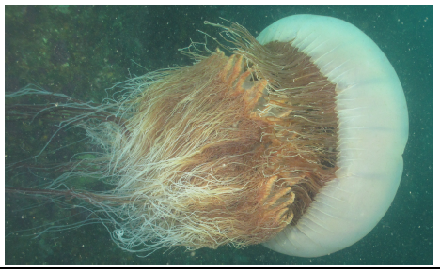
【Photo 1. Nomura’s Jellyfish】

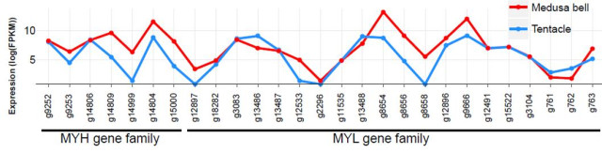
【Photo 2. Expression of MYH and MYL Genes in Head and Tentacles of Nomura’s Jellyfish 】
By comparing the expressed levels of MYH and MYL genes, which are the major proteins of muscle tissues, in the head (red line) and tentacles (blue line) of Nomura’s jellyfish, it was found that the expressed levels of MYH and MYL genes in the head of jellyfish, which controls movement, are higher than those of the tentacles.

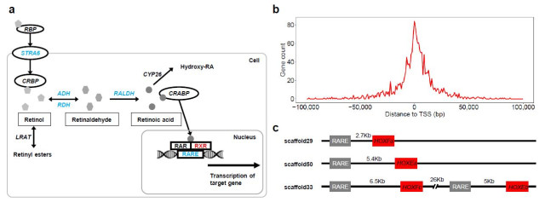
【Photo 3. Retinoic Acid Signaling System of Nomura’s Jellyfish】
a. Nomura’s jellyfish also contain essential elements of the human retinoic acid signaling system.
b. It was confirmed that the gene expression response around the retinoic acid response elements (RARE) of Nomura’s jellyfish was highly active.
c. The Hox* genes were found to be located around the retinoic acid reactive elements of Nomura’s jellyfish.
(*Hox genes are known to play a very important role in the formation of organisms’ bodies.)

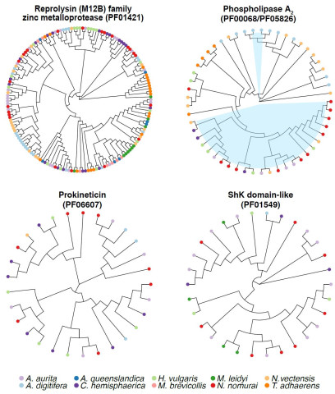
【Photo 4. Flexible relationships between the venom protein groups and domains of Nomura’s jellyfish and the homologous proteins found in primitive multicellular animals】
By comparing the homologous proteins found in primitive multicellular animals and the major protein groups and domains related to venom found in jellyfish, the diversity of venom proteins was confirmed.

